FOR IMMEDIATE RELEASE: Contact: Colleen Rice, Executive Director
exec@leadershipmedinacounty.org

Leadership Medina County Trustees Welcome New Members

{Medina County, Ohio, July 1, 2020} The Leadership Medina County Board of Trustees welcome the following new Board of Trustees Members:

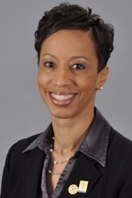
Radiah Blanton
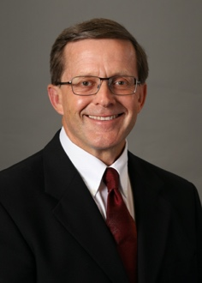
Rick Dumperth

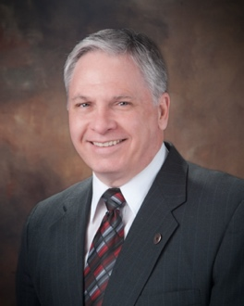
Stephen Hambley
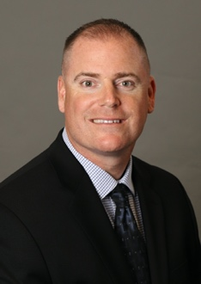
Edward Kinney
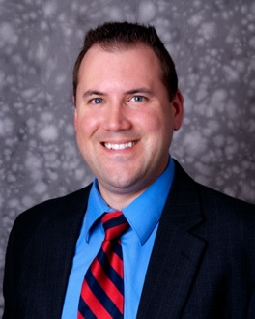
Theodore Klimczak
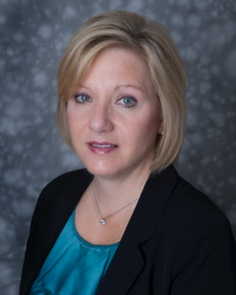
Kathy Warner
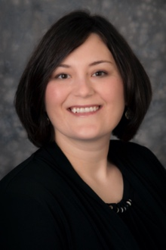
Jamie Stilla

Radiah Blanton, Class of 2016, currently serves as the Director at the Brunswick Campus of Cuyahoga Community college. She brings considerable knowledge and connections, having nurtured partnerships with many Medina County organizations such as the Northern Medina Chamber Alliance and the Medina County Economic Development Corporation.

Rick Dumperth, a graduate of the class of 2013, is a past trustee and has remained active in the organization ever since. He is very excited to once again participate on Leadership Medina County’s board. Rick currently works for Wolff Brothers Supply.
Stephen Hambley, Class of 1995, currently serves as the Ohio State Representative District 69. He is looking forward to continuing his good works in the community by serving on the Leadership Medina County board.
Edward Kinney, Class of 2019 is the current Chief of Police for the Medina City Police Department. Having recently completed the program himself, he is eager to continue the spirit of leadership on the board.
Theodore Klimczack, Class of 2014, is a Senior Manager of Tax Services at Rea and Associates, Inc. Of his upcoming experience, Ted said,
“I am excited for this opportunity and look forward to seeing the direction that this talented group of leaders, take our organization. I learned so much while going through the signature program. I met so many great leaders that I am still friends with today. I look forward to meeting many more in my new role on the board.”
Kathy Warner, Class of 2014, joins the board from Jobs for Ohio Graduates. There, she serves as the Program Director. Warner is no stranger to finding innovative ways to serve her community, having founded the non-profit First Impression, Inc. First Impression, Inc. a non-profit organization created to address the needs of challenged/displaced women trying to secure jobs. It provides gently used business attire and support to help increase the self-confidence and esteem of the clients.
The final addition to the LMC board is Jamie Stilla, Class of 2017. Jamie is the Manager of the Seville branch of the Medina County District Library.
"I'm so excited to take this next step with Leadership Medina County. What an honor and privilege to be able to take a key role within this outstanding organization that connects so many great leaders. I am up for the challenge and look forward to contributing at a higher level for the benefit of our amazing county." shared Jamie.
Leadership Medina County Officers are President Joel Hlavaty of Frantz Ward, LLP, Vice-President, Kimberly Bolas Miller, Westfield, Karen Gaub, Secretary, Dairy Farmers of America | Mideast Area and Josh Price, Treasurer, HHL Group, Inc. Of his new role, Hlavaty said,
Leadership Medina County would like to thank our retiring board members, Brooke Bell, Steve Chrisman, Medina County Career Center, Terri Grimm, Dean Harris, Western Reserve Transit Authority, Claus Meyer, Raymond James and Susan Ungham, retired.

XXX

