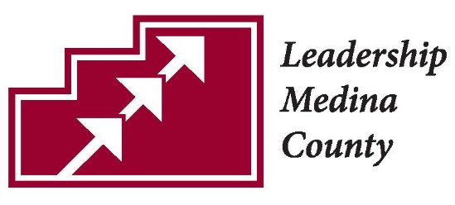
Leadership Medina County Nomination Form
Celebrating Excellence in Leadership
Deadline: May 31, 2018

Nominee Name
Position
Organization
Address
Phone
Email

Award which best represents this nominee:
- Excellence in Business Leadership
- Excellence in Education Leadership
- Excellence in Health Care Leadership
- Excellence in Public Service Leadership
- Excellence in Medina County Leadership
- Excellence in Emerging Leadership Award

Please write the reasons this nominee should be selected:

Nomination submitted by:
Name
Position
Organization
Address
Phone
Email
Relationship to nominee

